Assignment 1- Solution
1.
Frontend Development: The development that users see and directly interact with the server. It usually contains menu buttons, links, pictures and much more. It can be done with the help of most common languages like HTML, JavaScript, CSS.
Example: When we visit GLA website we see the login button, roll number filling column, captcha. This is all a part of frontend development.
Backend Development: The development that users can’t see. It makes the buttons usable. It stores data, checks login details and sends information to the frontend. It can be done by using Python, Java, Nodejs, MongoDB-Databases behind the screens.
Example: When we fill the login details on GLA firstly it checks then gives the access.
Full Stack Development: It is the combination of frontend and backend development. A full stack developer can create the entire application.
2.
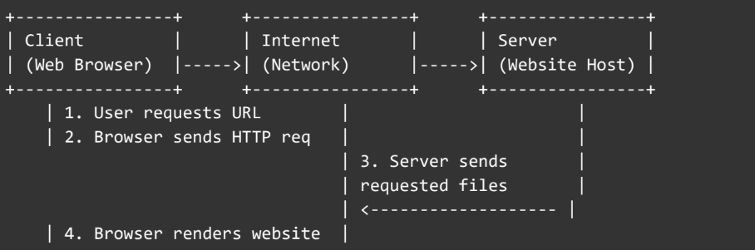
The above diagram shows how the client-server model works in web architecture.
3.
- The users enter a URL in browser.
- The browser sends an HTTP request to the web server.
- The server processes the request and sends back to the HTML, CSS and JavaScript files
- The browser renders the HTML and applies styles from CSS.
- JavaScript runs to make the page interactive.
- The page is displayed to the user.
4.
- Code editor (e.g., VS Code) – For writing and code and editing.
- Browser (e.g., Chrome, Edge) – To test and view web pages.
- Node.js – For running JavaScript outside the browser.
- Git – For version control and collaboration.
- Terminal/ Command prompt – For running development commands.
5.
A web server is software or hardware that serves web pages to users over the internet.
Examples: Apache, Nginx, Microsoft IIS, Node.js (Express), and LiteSpeed.
6.
- Frontend Developer – Designs and builds the user interface.
- Backend Developer – Develops server-side logic, APIs, and data handling.
- Database Administrator (DBA) – Manages, secures, and optimizes the database.
7.
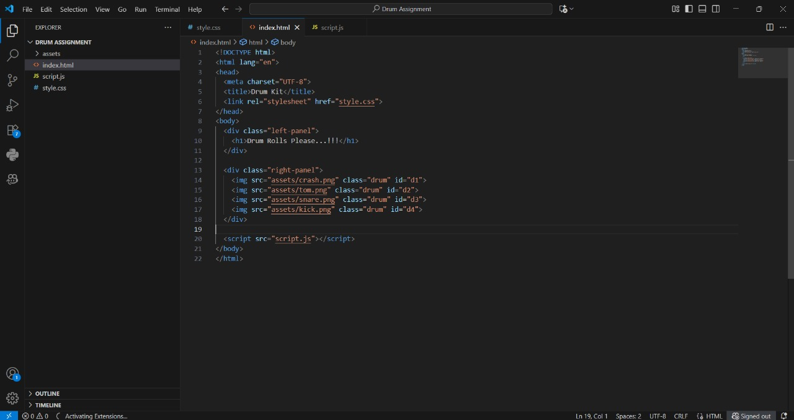
8.
Static websites display the same content for all users — created with HTML and CSS only.
Example: A personal portfolio website.
Dynamic websites generate content based on user interaction or database data.
Example: Facebook and Gmail.
9.
- Google Chrome – Blink engine
- Mozilla Firefox – Gecko engine
- Microsoft Edge – Blink engine
- Apple Safari – WebKit engine
- Opera – Blink engine
Different engines interpret and render HTML/CSS/JS differently, which can affect page layout and performance.
10.
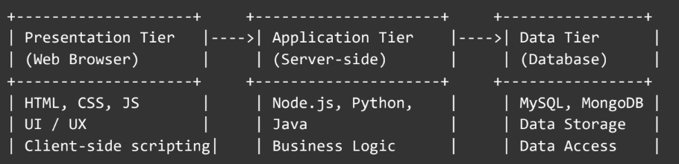
The above diagram shows the basic web architecture flow — client, server,
database, and APIs.

